**Birla Institute of Technology and Science Pilani, Dubai Campus**

**Dubai International Academic City**

**CS/ECE/INSTR/EEE F241**

**MICROPROCESSORS AND INTERFACING**

**LABORATORY MANUAL**

**II Semester 2021-22**

**CYCLE I**

**EXPERIMENT 1**

**P1. Write a program to add two 2-digit hexadecimal numbers available in**

**memory and store the result in memory.**

**Handwritten code/program:**

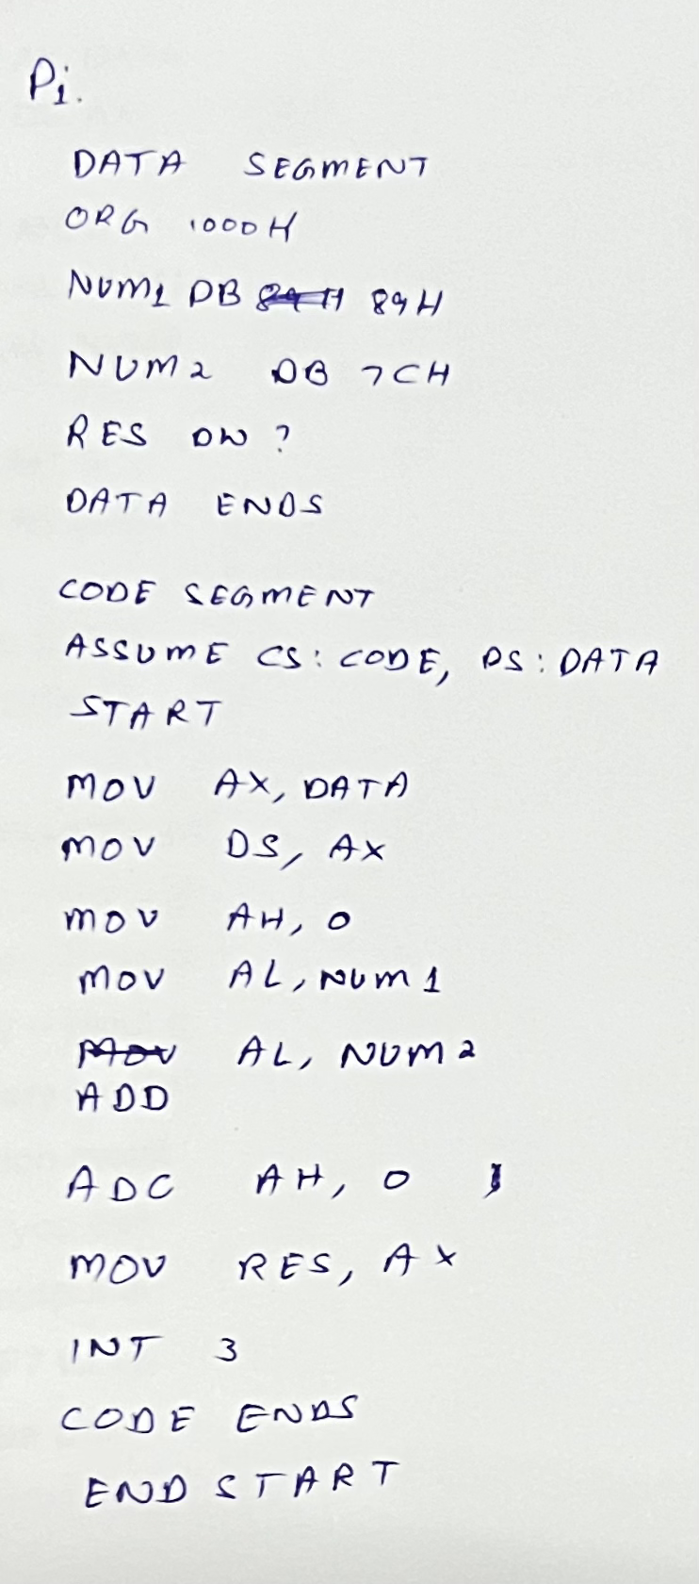

**Result:**

Num 2

Lower

byte

Upper

Byte

Num 1

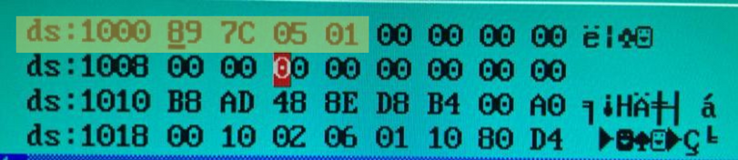 **P2: Assembly Program: addition of 2 hex numbers?**

**Handwritten code/program:**

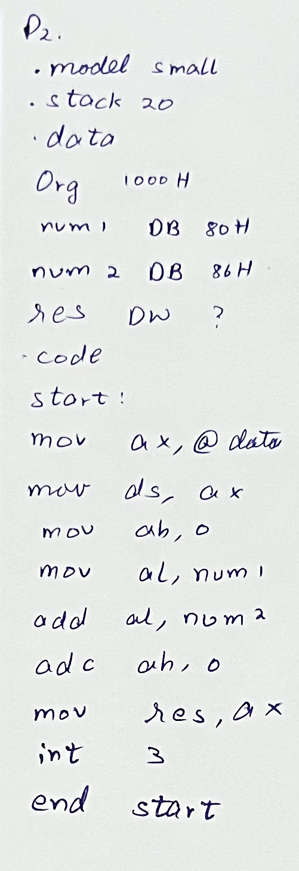

**Result:**

Lower

byte

Upper

Byte

Num 2

Num 1

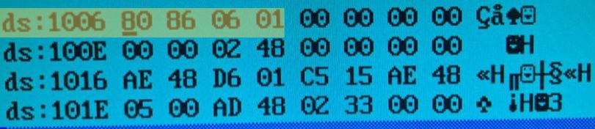  
  
**P3. Write a program to add two 2-digit decimal numbers available in memory**

**and store the result in memory.**

**Handwritten code/program:**

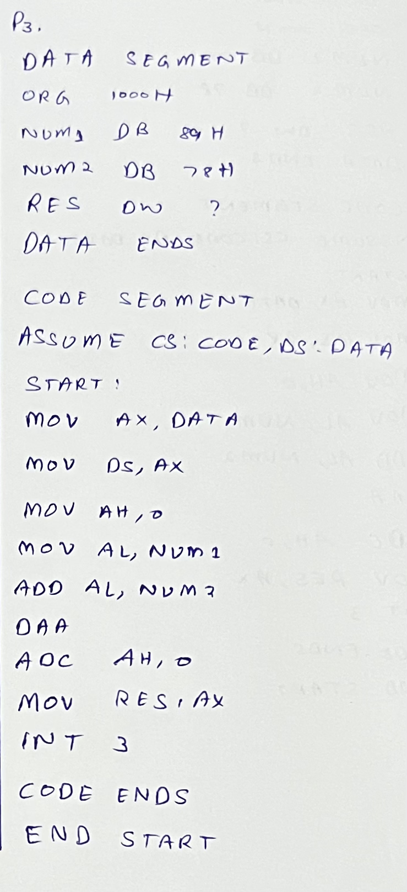

**Result:**

Lower

byte

Upper

Byte

Num 2

Num 1

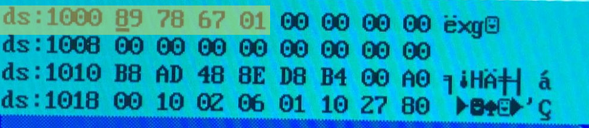 **P4: The above program without H in the input Data**

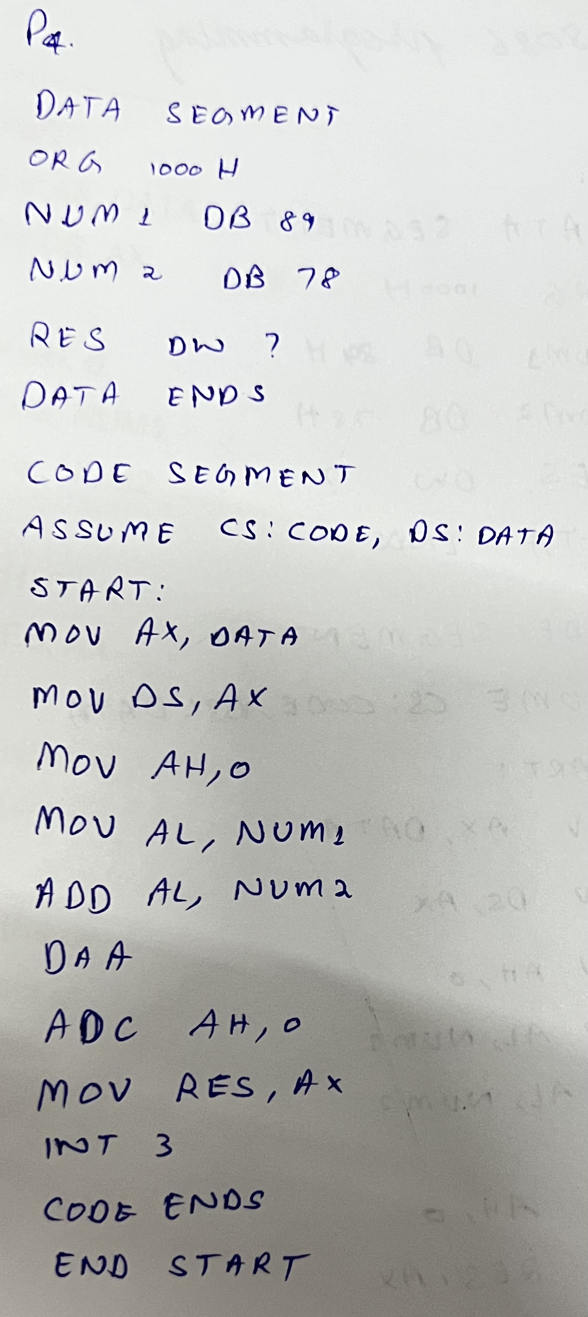

**Result:**

Num 1

Lower

Byte

Upper

Byte

Num 2

